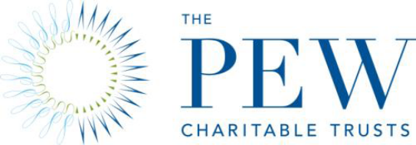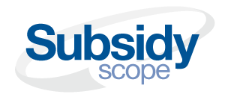

Pew Launches Project to Examine Federal Subsidies
Contact: Jeremy Ratner, 202.552.2137
Washington, DC - 12/15/2008 - With the role of government in financial markets rapidly expanding, The Pew Charitable Trusts today announced a new project to focus public and policymaker attention on the size and scope of all federal subsidies. Subsidyscope, an initiative of Pew’s Economic Policy Department, will aggregate information on subsidies from multiple sources into a comprehensive, searchable, open-source database, which will serve as a gateway for press, policymakers, advocates and the public. The project will be guided by a broad and bipartisan advisory board of budget, fiscal and transparency experts. The board met in Washington today to launch the project.
"The current financial crisis has led to historic market interventions by the federal government and has invigorated the national debate about the appropriate role of government in the economy,” said John E. Morton, managing director of Pew’s Economic Policy Department. “Too often policymakers speak as if subsidies are limited to direct expenditures on assorted social programs. The reality is that, increasingly they flow through the tax code and are not subject to the same level of public oversight. In our fiscally constrained environment—and with government interventions shifting new burdens onto American taxpayers—there is more need than ever for a comprehensive and transparent fact base to inform future discussions about subsidies.”
“Federal subsidies go well beyond direct payments from the federal government to private businesses,” said Douglas Hamilton, deputy director of Pew’s Economic Policy Department. “They also include tax breaks for individuals and corporations, loan guarantees, stock purchases and other financial interventions. And they’re massive. By some accounts, the tax breaks for individuals alone cost hundreds of billions of dollars a year.”
Pew will work closely with representatives of partner organizations to call attention to the study of subsidies, both in the project, but also through the work of contributing organizations.
“By working together, we believe that we can improve the definition of what constitutes subsidies, and highlight the full extent of their reach in the market,” said Morton. “In this phase of the project, we won’t take a position on whether certain subsidies are better than others – we want to move the facts into the public arena. We hope the data are used by advocates on all sides of the issue.”
Pew has engaged the Sunlight Foundation, a national leader on matters of government transparency, as its technology partner on the project. Sunlight will be responsible for constructing the technical infrastructure, compiling data and building Subsidyscope’s database.
”This project represents an exciting opportunity to shine a light on various ways that increasingly scarce federal resources are being spent,” said Ellen Miller, the Sunlight Foundation’s co-founder and executive director. “While we don’t know precisely what the project will find, as Supreme Court Justice Louis Brandeis famously said, ‘Sunlight is the best disinfectant.’”
During the course of developing the database, Subsidyscope will release regular reports, aggregating and analyzing subsidies to various industry sectors.
For more information, please visit Subsidyscope.com.

